# **Project on: To scrape the contact details of book authors globally and their book details too.**

The data was scraped from <https://books.toscrape.com/>.

Following is the snapshot of the website look:

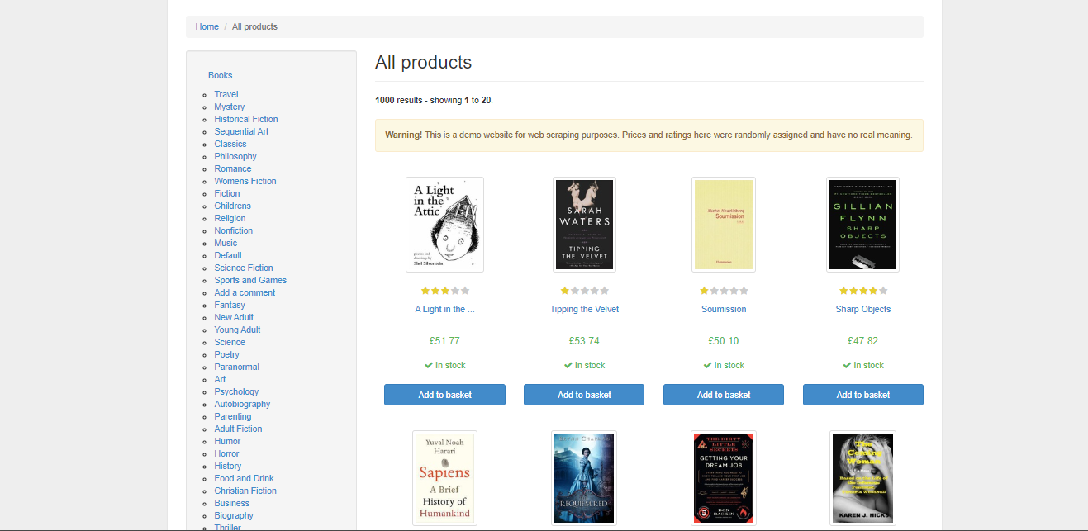

While performing on the scraping first steps was to import the important libraries which are essential to perform the web scraping.

Afterward we have to use to url of the website which we have to scrap the data. Then we will be requesting the url and perform some process to ger all the html data into our working environment to perform the data collection process.

Once that process is done first, we will collect the data of only one page to check is our code is working correctly or not. Once the code if running correctly on the page one we can implement the same code in the loop of the numbers of pages as per our requirements. As this website contain 50 pages but I was able to scrap the data of 15 pages due to system problem.

**To see complete code/ Notebook :** <https://drive.google.com/file/d/1x6EQNlruVdG3FZ91iFYSeixJwi9mcpHj/view?usp=drive_link>

Following are some snapshots of my scrap data before saving it into the csv format.

Title: A Light in the Attic

Category: Poetry

Rating: Three

Price: £51.77

Availability: In stock (22 available)

Description: It's hard to imagine a world without A Light in the Attic. This now-classic collection of poetry and drawings from Shel Silverstein celebrates its 20th anniversary with this special edition. Silverstein's humorous and creative verse can amuse the dowdiest of readers. Lemon-faced adults and fidgety kids sit still and read these rhythmic words and laugh and smile and love th It's hard to imagine a world without A Light in the Attic. This now-classic collection of poetry and drawings from Shel Silverstein celebrates its 20th anniversary with this special edition. Silverstein's humorous and creative verse can amuse the dowdiest of readers. Lemon-faced adults and fidgety kids sit still and read these rhythmic words and laugh and smile and love that Silverstein. Need proof of his genius? RockabyeRockabye baby, in the treetopDon't you know a treetopIs no safe place to rock?And who put you up there,And your cradle, too?Baby, I think someone down here'sGot it in for you. Shel, you never sounded so good. ...more

*******************

Title: Tipping the Velvet

Category: Historical Fiction

Rating: One

Price: £53.74

Availability: In stock (20 available)

Description: "Erotic and absorbing...Written with starling power."--"The New York Times Book Review " Nan King, an oyster girl, is captivated by the music hall phenomenon Kitty Butler, a male impersonator extraordinaire treading the boards in Canterbury. Through a friend at the box office, Nan manages to visit all her shows and finally meet her heroine. Soon after, she becomes Kitty's "Erotic and absorbing...Written with starling power."--"The New York Times Book Review " Nan King, an oyster girl, is captivated by the music hall phenomenon Kitty Butler, a male impersonator extraordinaire treading the boards in Canterbury. Through a friend at the box office, Nan manages to visit all her shows and finally meet her heroine. Soon after, she becomes Kitty's dresser and the two head for the bright lights of Leicester Square where they begin a glittering career as music-hall stars in an all-singing and dancing double act. At the same time, behind closed doors, they admit their attraction to each other and their affair begins. ...more

*******************

Title: Soumission

Category: Fiction

Rating: One

Price: £50.10

Availability: In stock (20 available)

Description: Dans une France assez proche de la nôtre, un homme s’engage dans la carrière universitaire. Peu motivé par l’enseignement, il s’attend à une vie ennuyeuse mais calme, protégée des grands drames historiques. Cependant les forces en jeu dans le pays ont fissuré le système politique jusqu’à provoquer son effondrement. Cette implosion sans soubresauts, sans vraie révolution, s Dans une France assez proche de la nôtre, un homme s’engage dans la carrière universitaire. Peu motivé par l’enseignement, il s’attend à une vie ennuyeuse mais calme, protégée des grands drames historiques. Cependant les forces en jeu dans le pays ont fissuré le système politique jusqu’à provoquer son effondrement. Cette implosion sans soubresauts, sans vraie révolution, se développe comme un mauvais rêve.Le talent de l’auteur, sa force visionnaire nous entraînent sur un terrain ambigu et glissant ; son regard sur notre civilisation vieillissante fait coexister dans ce roman les intuitions poétiques, les effets comiques, une mélancolie fataliste.Ce livre est une saisissante fable politique et morale. ...more

Once all the data get scraped, we will save the scraped data into CSV format to do the further analysis / prediction.

Snapshot of CSV file is follow:

Also you can refer the drive link to see all the output data:

<https://drive.google.com/file/d/1pKZWLphfOZwpqHDD6NRXHRxdENV5REIK/view?usp=drive_link>

